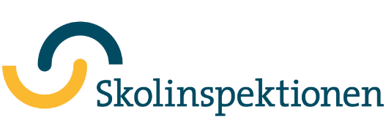
Information for the guardians about the School survey
Hello!
Now it’s time for the School survey. The School survey is an online survey addressed to parents/guardians, students and educational staff. The questionnaire is available to be answered from 2024-01-22 to 2024-02-23.
All children and teenagers have the right to a good education in a safe environment. The Swedish school inspectorate is a governmental regulatory agency to check that all schools meet these requirements. The survey results provide an important basis for the school inspectorate supervision which aims to contribute to a better school with better results. Some of the results will also be compiled into statistics and sent over to the education department information service for parents and students.
You as guardians of children in pre-school, primary or special primary school have the opportunity to share your views about the school through the school survey. The school survey can be answered on the website and it takes about 10 minutes to answer. If you have several children at the school in question, you need to answer the survey for each and every child separately. The results will be presented in a compiled form and will not be disclosing any information that can damage any individual. The responses will not be processed by the school, but by the Swedish Schools Inspectorate.
The school survey will also be answered by the educational staff, pupils in primary school grades 5 and 8 and upper secondary grade 2. Students will answer the survey during school hours. If you have a child in grade 5 and do not want her/him to answer the questionnaire, you should notify the school.
To answer the questionnaire:
- Click the following link www.skolinspektionen.se/skolenkaten
- Parents/Guardians of children in primary and special primary school: Click on ”föräldrar/vårdnadshavare med barn i förskoleklass, grundskola eller anpassad grundskola” Answer the questionnaire from 2024-01-22 to 2024-02-23.
- Enter the password which is specified in the right corner in the information letter that you received from your child's school.
If you have questions about the codes and login information, please contact Origo Group on the phone 013-465 61 00 or skolenkaten@origogroup.com. If you have other questions about the school survey, please get in touch with us via the Schools Inspectorate's phone 08-586 080 00 or e-mail skolenkaten@skolinspektionen.se.
For more information on the school survey, go to www.skolinspektionen.se/skolenkaten.
Thank you for taking your time to complete the survey. It is important for us to know what you think of your/your child's school!
Sincerely,
The Swedish Schools Inspectorate

